**Electric Circuit ( LAB Report )**

Name : Khaled Mofdi Alshammri

Experiment : 6 ( Superposition Theorem )

Introduction :

In this experiment I will study the superposition in the circuit [ pic 1 ] .

“ The voltage and current responses in a network from two or more sources acting simultaneously can be obtained as the sum of the responses from each source acting alone with other sources deactivated. A deactivated current source is an open circuit. A deactivated voltage source is a shortcircuit. “

[ Pic 1 ] Circuit with 2 voltage Source and 5 Resistor’s

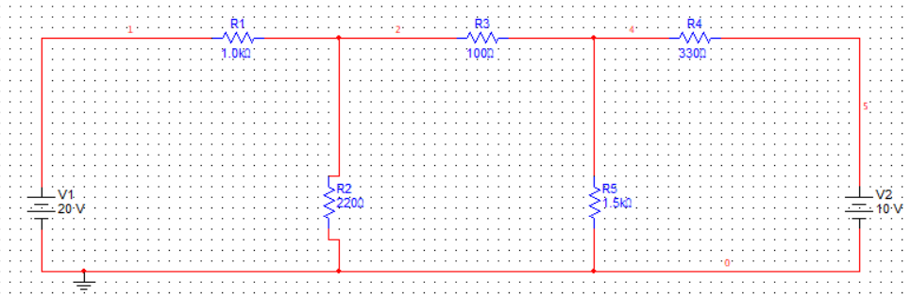

1 ] Measurement Voltage and Current in Circuit with two source 20V and 10V

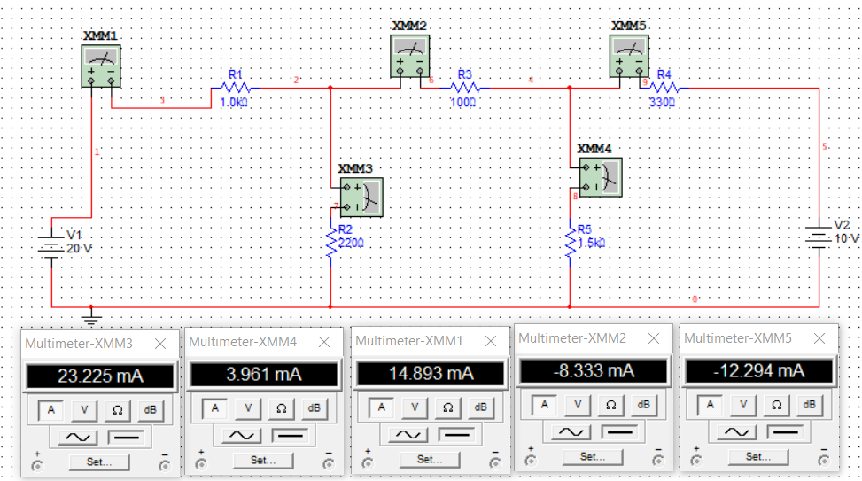

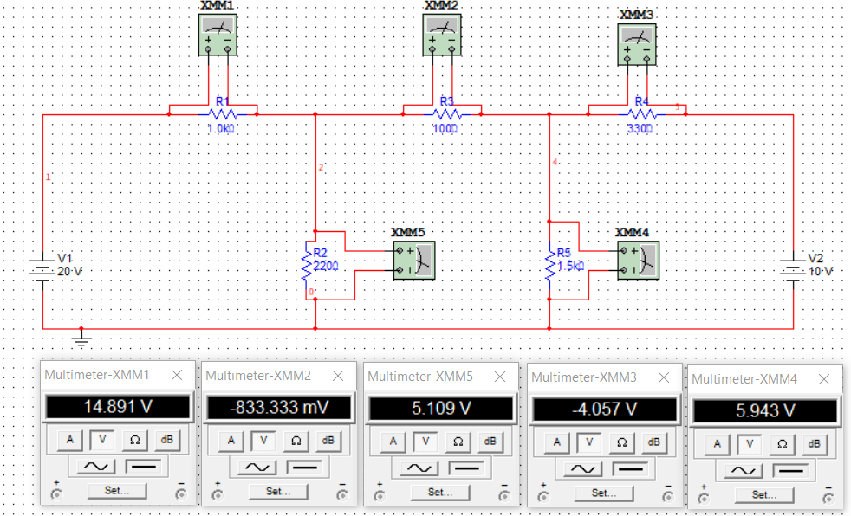

Table 1 :

|  |  |  |  |  |  |
| --- | --- | --- | --- | --- | --- |
| Resistors | 1kΩ | 220Ω | 100Ω | 1.5kΩ | 330Ω |
| Voltage | 14.891 v | 5.109v | -833.333 mV | 5.943 v | -4.057 v |
| Current | 14.893 mA | 23.225 mA | -8.333 mA | 3.961 mA | -12.294 mA |

2 ] Remove 10V source from the Circuit and measurement voltage and current

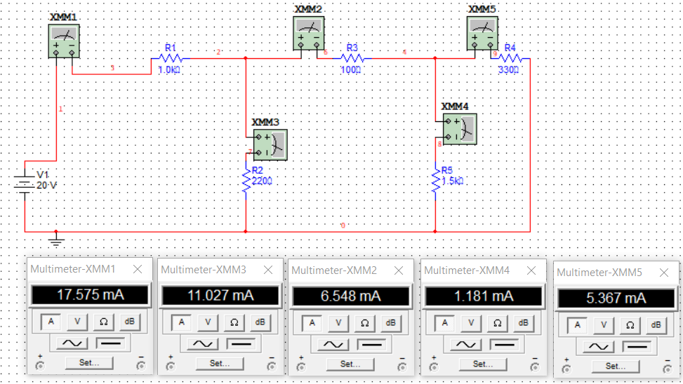

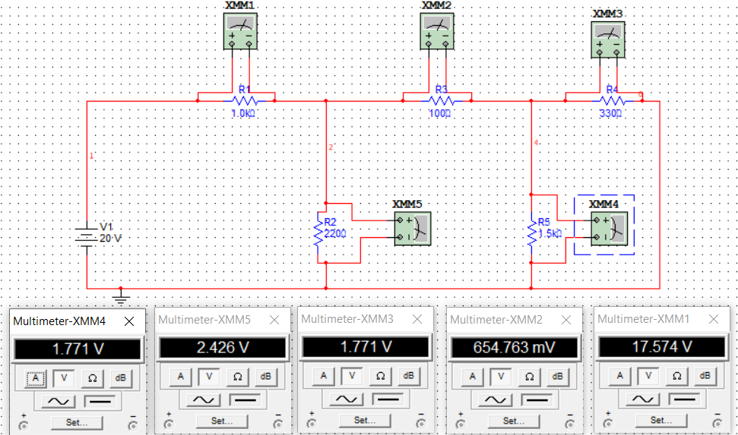

Table 2 :

|  |  |  |  |  |  |
| --- | --- | --- | --- | --- | --- |
| Resistors | 1 kΩ | 220Ω | 100Ω | 1.5kΩ | 330Ω |
| Voltage | 17.574 v | 2.426 v | 654.763 mV | 1.771 v | 1.771 v |
| Current | 17.575 mA | 11.027 mA | 6.548 mA | 1.181 mA | 5.367 mA |

3 ] Remove 20V source from the Circuit and put 10V source back to the circuit and measurement voltage and current

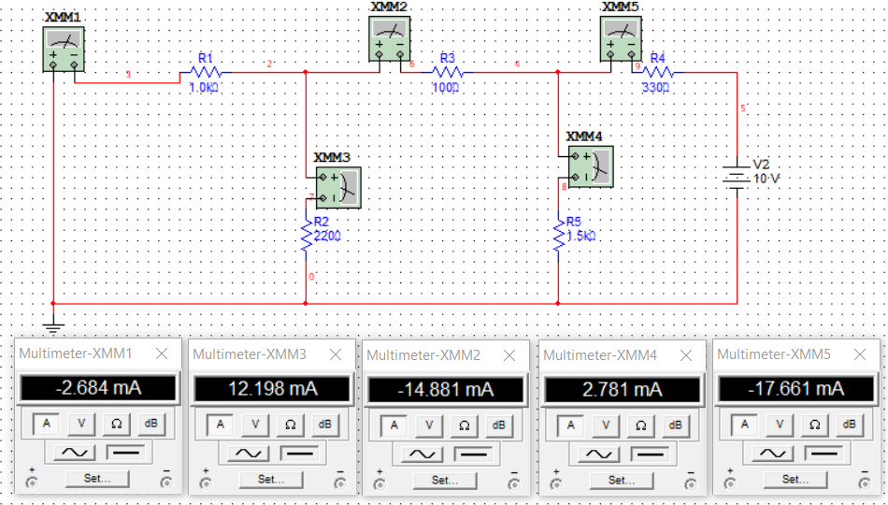

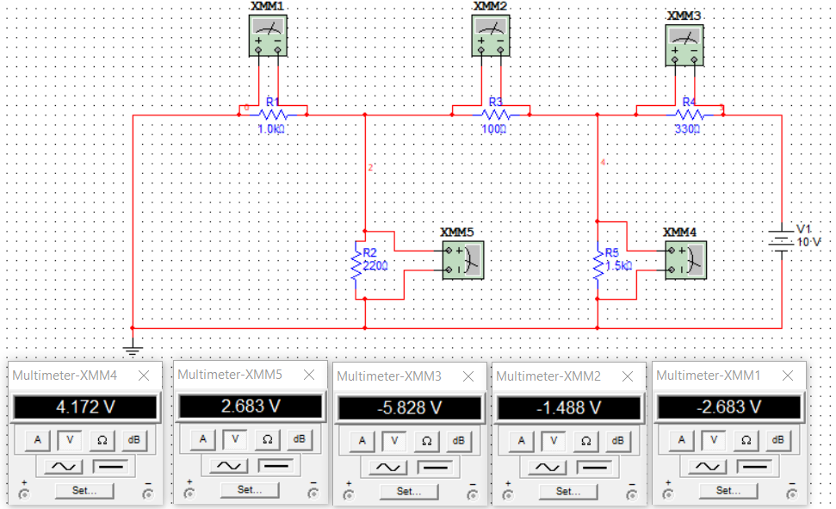

Table 3 :

|  |  |  |  |  |  |
| --- | --- | --- | --- | --- | --- |
| Resistors | 1 kΩ | 220Ω | 100Ω | 1.5kΩ | 330Ω |
| Voltage | -2.683 v | 2.683 v | -1.488 v | 4.172 v | -5.828 v |
| Current | -2.684 mA | 12.198 mA | -14.881 mA | 2.781 mA | -17.661 mA |

**Question**:

**1** ] Check for superposition principle. Enter your observations here.

Answer : yes , superposition is applied

**2** ] Superposition theorem applies for only certain types of circuit. State what is the type?

Answer : in both parallel and series circuit and circuit have Source voltage and current and can’t applied in power or other another

**3** ] Superposition applies to only some variables or quantities like current and voltage. It

does not apply to, for example, power. State why not.

Answer : In simple words the equation of power is non-linear hence homogeneity and superposition, none is valid. And if I use power I need voltage or current ( P = IV ) or ( P=V2/R)

**Conclusion** :

In this experiment, I learned that Superposition can be applied to parallel and series circuits.( linear circuit ) and not applied with non linear Circuit

And cant use power with superposition.